Module 1: Introduction

Tom Carruthers, Adrian Hordyk

# Exercise 1: Online Demonstration

## Introduction

In this exercise you will explore the online demo of DLMtool. The demo was built using an application called R Shiny, which allows users to modify and run models built in R using a user-friendly interface and without having to type any R code. However the online application is not as flexible or customizable as the full version of the DLMtool.

The online demo is useful for building an understanding of the MSE process, and having a first look at building operating models, selecting performance metrics, and examing trade-offs among alternative management strategies.

All results here are for demonstration purposes only.

## Data-Limited Toolkit Website

The online demo is available on the [Data Limited Toolkit](http://www.datalimitedtoolkit.org) website. Head to <http://www.datalimitedtoolkit.org/demo> in your web browser and click the 'Start the Demo' button. It may take a few seconds for the application to load.

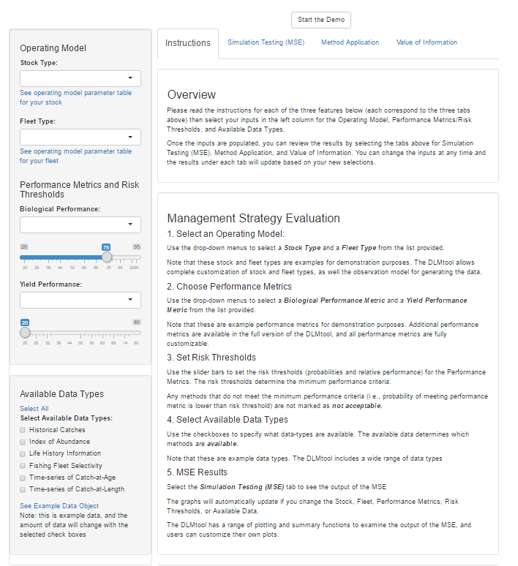

Screenshot of the DLMtool Online Demo

## Scenario 1

### Operating Model

Select Stock Type **Sole** and Fleet Type **Stable Effort**.

### Performance Metrics

An **Acceptable** MP must have at least 70% probability of $B>0.5B_{MSY}$ and an expected long-term of at least 50% of that expected from fishing perfectly at $F_{MSY}$.

### Available Data Types

The availabe data types are **Historical Catches** and an **Index of Abundance**.

### Questions

* Identify a Management Procedure from the Trade-Off plot that you think is the best candidate for managing the fishery. Why do you think this is the best available method?
* How does the method perform in terms of **Short-Term Yield**?
* Examine the trade-offs among the best performing methods with respect to Short and Long-Term Yield. Why do some MPs have high short-term yield but relatively low long-term yield? You can look at the projection plots of the different methods to compare the performance of two MPs over time.
* If the method you've identified as the best candidate is not currently available, what additional data are required?
* How does the performance of this method change under conditions of increasing fishing effort?

## Scenario 2

### Operating Model

Select Stock Type **Albacore** and Fleet Type **Stable Effort & Targetting Small Fish**.

### Performance Metrics

An **Acceptable** MP must have at least 80% probability of $B>0.5B_{MSY}$ and an expected long-term of at least 50% of that expected from fishing perfectly at $F_{MSY}$.

### Available Data Types

Select all data types.

### Questions

* Identify the top two performing MPs and explain why you believe these are the best candidates.
* How does the performance of these MPs compare and which would you select as the better candidate? Use the projection and Kobe plots to examine the performance of the two methods.
* How does the performance of these methods change under conditions of increasing fishing effort? Which of these MPs is most robust to future increases in fishing effort?
* Identify the worst performing method. Is this MP the worst performing method under all fleet types?
* Given what you know about the Stock (you can see the Stock parameters by clicking the link below the selected stock), why do you think this method performs so poorly? Under what conditions would you expect the performance of this method to improve?

## Scenario 3

### Operating Model

Select Stock Type **Albacore** and Fleet Type **Stable Effort & Targetting Small Fish**.

### Performance Metrics

An **Acceptable** MP must have at least 80% probability of $B>0.5B_{MSY}$ and an expected long-term of at least 50% of that expected from fishing perfectly at $F_{MSY}$.

### Questions

* Identify the best performing method with respect to these performance metrics. What data are required in order for this MP to be Available?
* What method would you select if all data types were available? What additional data are required to unlock this MP?
* If you know something about this MP, consider the assumptions of the method and whether they are likely to hold in a data-limited fishery. You may be able to use the DLMtool documentation to find more information on the MP.
* The *ItargetE4* method appears to have high probability that biomass is above $0.5B_{MSY}$ but relatively low expected yield compared to other methods. Why do you think this is? Use the projection and Kobe plots to examine the performance of the two methods.